**Feedback Management System**

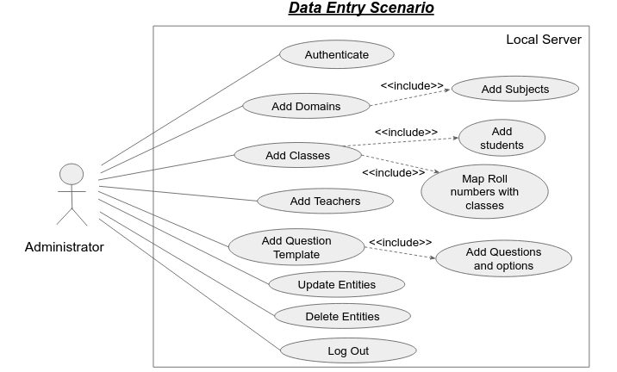

**Name :** Data Entry Scenario

**Identifier :** FSUC01

**Description :**

The use case describes and elucidates the functionality of entering the data into the feedback database. The administrator will be the only actor for the use case. Administrator will be able to enter the teacher, subject, classes, students and other semester data into the system and can also upload it via excel sheets. After filling the data administrator can also map these entities and after all of this process administrator can also update or delete the entities.

**Preconditions :**

1.Administrator should have authorized access to the system.

2.Database should have table with relevant schema.

3.Administrator should have appropriate data which is to be entered.

**Goal :**

The goal of the use case is to demonstrate the functionality of data entry in the feedback system.

**Assumptions :**

1. Server system should have all library dependencies installed.

2. Server system should have local network connectivity.

**Frequency :**

1.Once a semester.

**Basic Course :**

1. Use case starts when the new feedback for new semester is initiated.

2. The administrator starts with adding domains.

3. Then the administrator adds the respective subjects.

4. Then the administrator adds classes and respective students.

5. Roll no and classes are mapped automatically as soon as classes are added.

6. The questions and templates are then added.

7. Map the questions with their respective templates

8. Add options for each questions.

9. The option for updating the entities becomes visible and entities can be updated.

10.The option for deleting the entities becomes visible and entities can be deleted.

**Alternate Course A: Roll no out of range**

**Condition :** Roll number range entered is already assigned to another class.

A.1 The system checks whether the students range is already present

A.2 If conflict occurs, system throws error pop up

A.3 Administrator need to enter the valid range

**Alternate Course B: question options**

**Condition :** Unique option values

A.1 The system checks how many number of options are being entered in the system.

A.2 If 2 options then 100 and 0 marks are assigned as in True and False.

A.3 If all 5 options are entered then marks are assigned in descending order.

A.4 Else error is thrown.

**Post conditions :**

1. Server system changes should be saved

2. System should be logged out.

**Actors :**

1. Administrator

**Included Use Cases :**

1. Add subject

2. Add student

3. Add student mapping

4. Add classes

5. Add Teachers

6. Add Question Template

7. Add Questions and options

8. Update entities

9. Delete entities

**Extended Use Case :** None